TC-DM-003
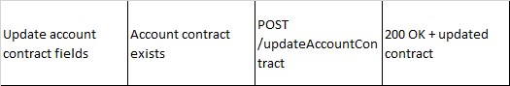
Account Before Update
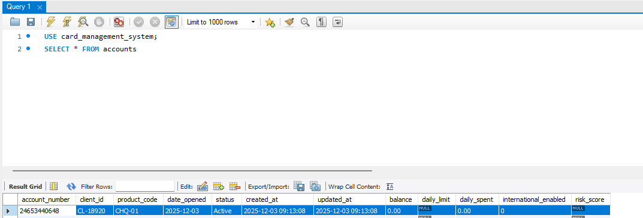
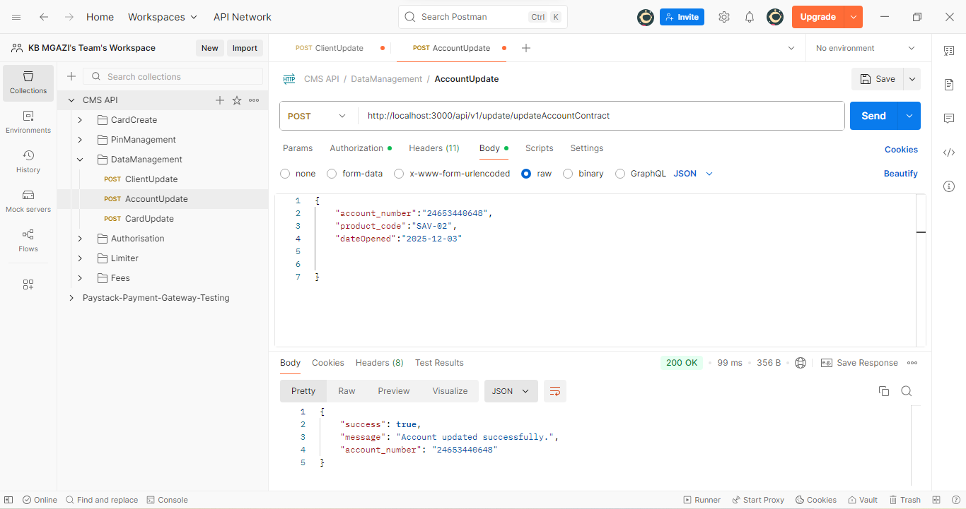
Request :
{
"account_number":"24653440648",
"product_code":"SAV-02",
"dateOpened":"2025-12-03"

}

Response:
{
"success": true,
"message": "Account updated successfully.",
"account_number": "24653440648"
}

